1. **Agenda**:
   1. What is redis sentinel?
   2. How it works?
   3. How it provides high availability for your system?
2. If there is only one instance and that is down. You’re doomed as your app stores data in redis.
3. To solve this problem, you could add slaves to replicate your master and then just read it from the slaves until your master comes up again.
4. This is one way to do it but there are more ways to do that.
5. 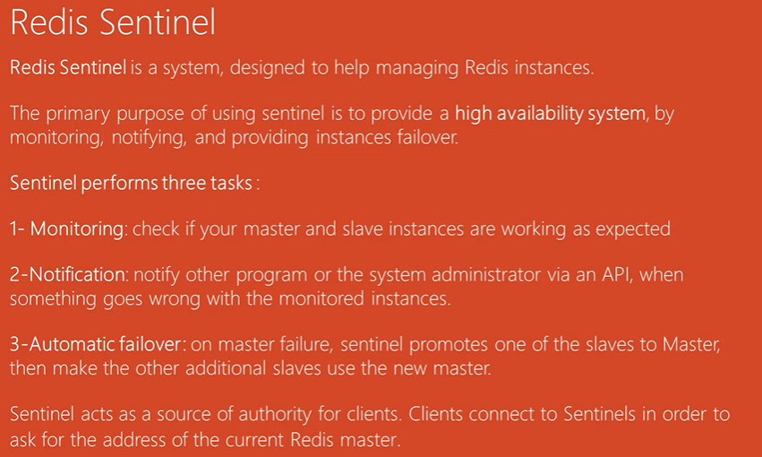
6. Let’s see sentinel works deeply.
7. We have another layer where we setup sentinels running on separate servers but that is not necessary. They monitor master and slave nodes.
8. First request goes to sentinels which act as source of authority and tells which master is in action.
9. The responsibility of sentinel is to detect when master goes down  
   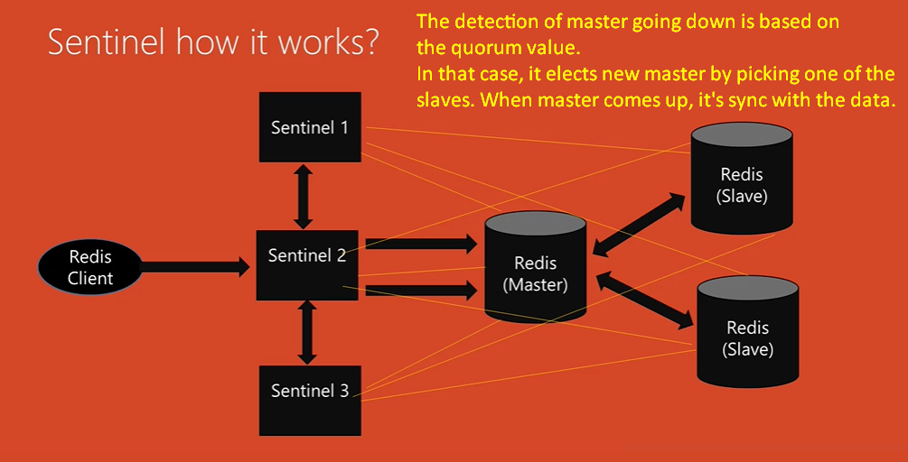
10. It takes few seconds to find when master is down. This is based on your configuration and we will see that later.
11. 